Camelot Centre  Golf Classic  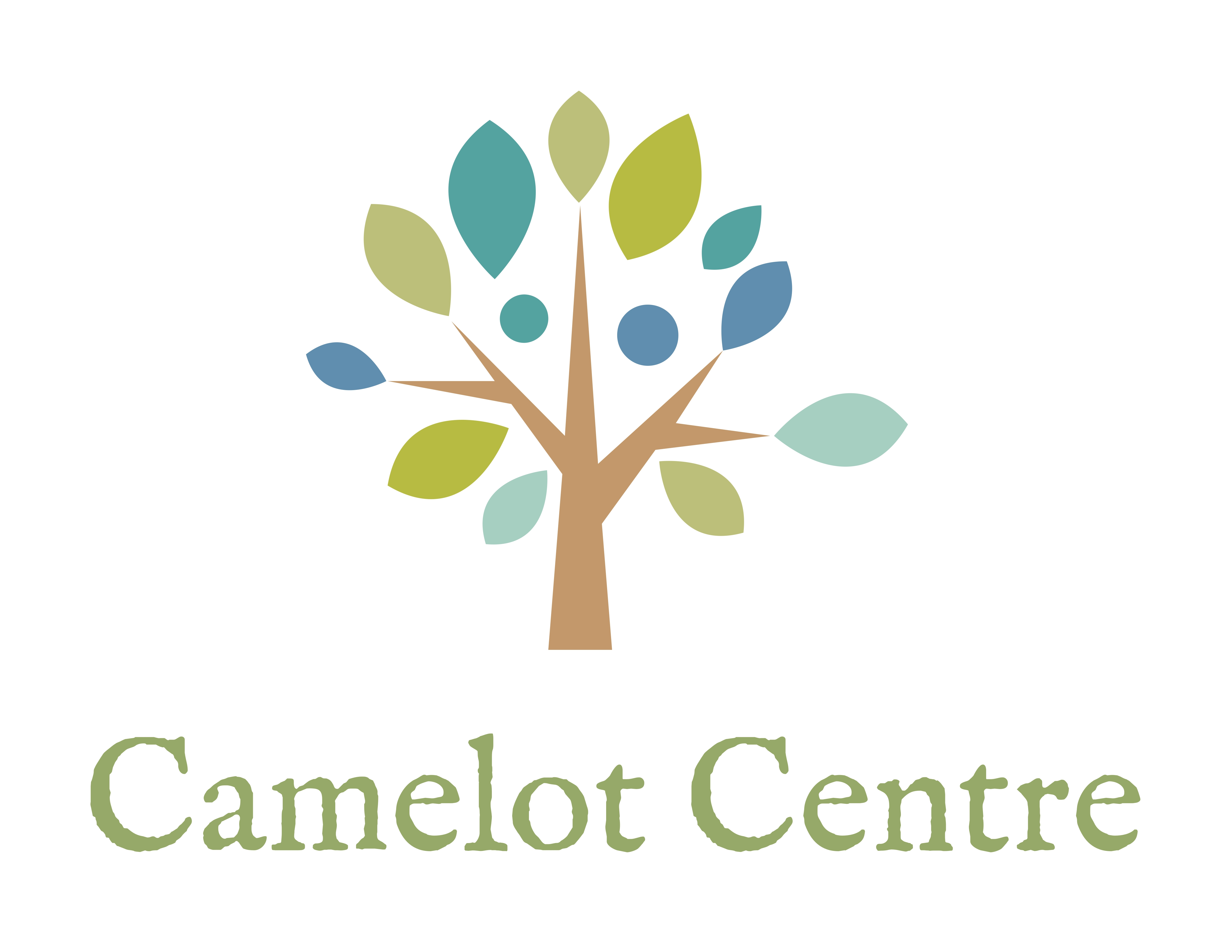 | September 16, 2025  Dundas Valley Golf & Curling Club  10 Woodleys Lane, Dundas ON  905-628-6731  CONTACT: BONNIE SYLVIA. 416-605-0728  GOLFER REGISTRATION. Entry Deadline: September 1, 2024  SHOTGUN START AT 12:30PM
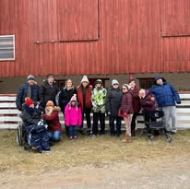 | 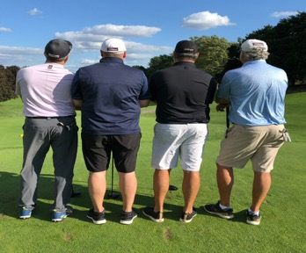

  - The tournament is held at Dundas Valley Golf & Curling Club, home to one of Canada’s Top 100 Golf courses. Known for exceptional service and amenities, set within the Niagara Escarpment, they offer an inviting and relaxing atmosphere amongst incredible natural splendor.

  - You will be supporting the excellent work of Camelot Centre in providing day programs for young adults with developmental disabilities. CRA #805239548
Please complete the registration form, attached to this email,
and return to camelotcentre@gmail.com.
Note changes in payment process this year!

SPONSORSHIP  TYPE | King  Arthur | Prince  Valiant | Sir  Lancelot | Sir Galahad’s  Putting Contest | Knight’s  Hole Sponsor
Sponsorship Amount | $5,000 | $2,500 | $1,250 | $500 | $100
Complimentary foursome
Complimentary twosome
Acknowledgement as patron in program
Signage in registration area
Holes
Acknowledgement on website, Instagram & Facebook pages

PLEASE COMPLETE AND RETURN THE GOLFER REGISTRATION FORM TO camelotcentre@gmail.com.
GOLFER REGISTRATION FEE: $250/golfer

PAYMENT AS FOLLOWS:

Cheques payable to Camelot Centre, with golf tournament on memo line, can be mailed with the registration form to Camelot Centre 370 Shoreacres Rd, Burlington, ON. L7L 2H5
E-transfers may be sent to camelotcentre@gmail.com
Credit card payments (Visa, Mastercard & Amex) by contacting Bonnie Sylvia 416- 605-0728 or 905 632-2396

Charitable tax receipts are issued for the giftable portion of sponsorship amount; prize donations at market value or if invoice is provided or the amount received at auction.

You will enjoy a fabulous day of golf on a quality private course, lunch and dinner, prizes, raffles and opportunities to bid on an exciting, exclusive online auction.

For further information contact: Bonnie Sylvia bsylvia0211@gmail.com 416-607.0728
President, Camelot Centre
Jessica Turner camelotcentre@gmail.com 905-633-7700
Program Co-Ordinator

